HOTMIXPRO SMOKE
LOGISTIC DETAILS  - MACHINE SIZE: mm. 276 W x 163 D x 266 H (including any protruding stuff)  - WEIGHT: KG 4,50  - PACKED MACHINE (ON A PALLET): 35 L. X 25 D. X 30 H CM  - PACKED WEIGHT: KG 6,00  - N.48 UNITS ON N.1 PALLET 120X80 (MAX)  - HS CODE: 85098000 | 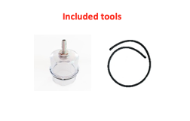 | 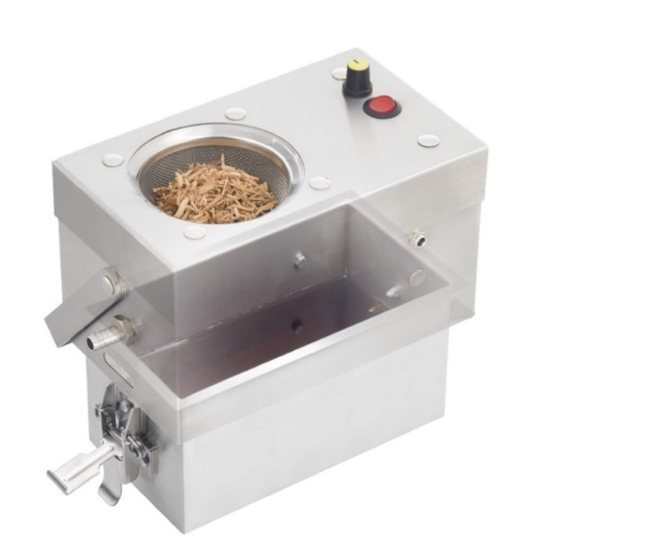

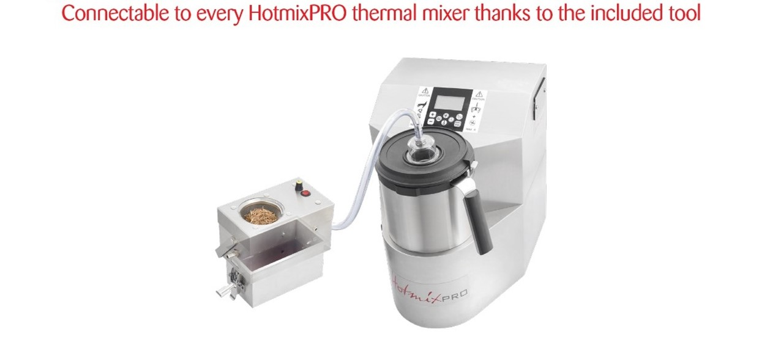

PRODUCT SPECIFICATIONS
Flow Regulation | Volume camera (liquid) | Power | Body
Yes | 2 Lt. max | 24W | Stainless steel

